Permanent Delete Account

User Flow

IAM
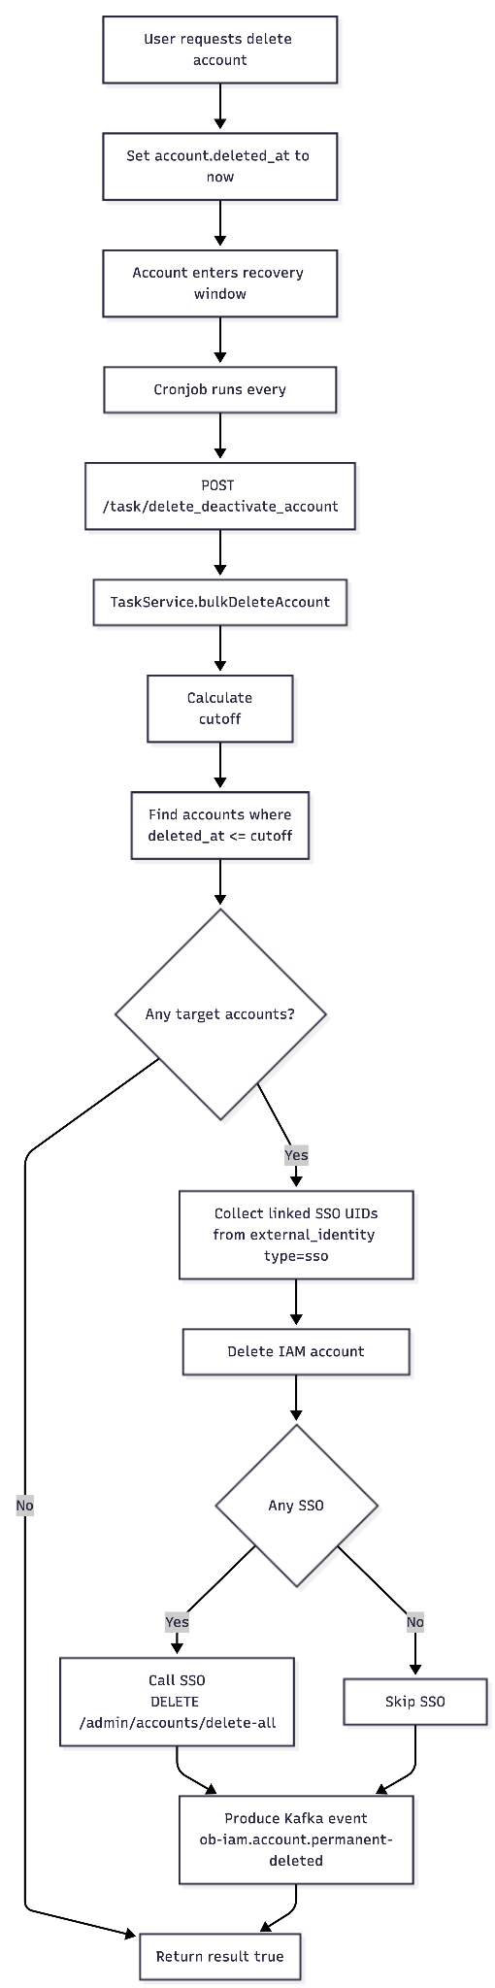

SSO
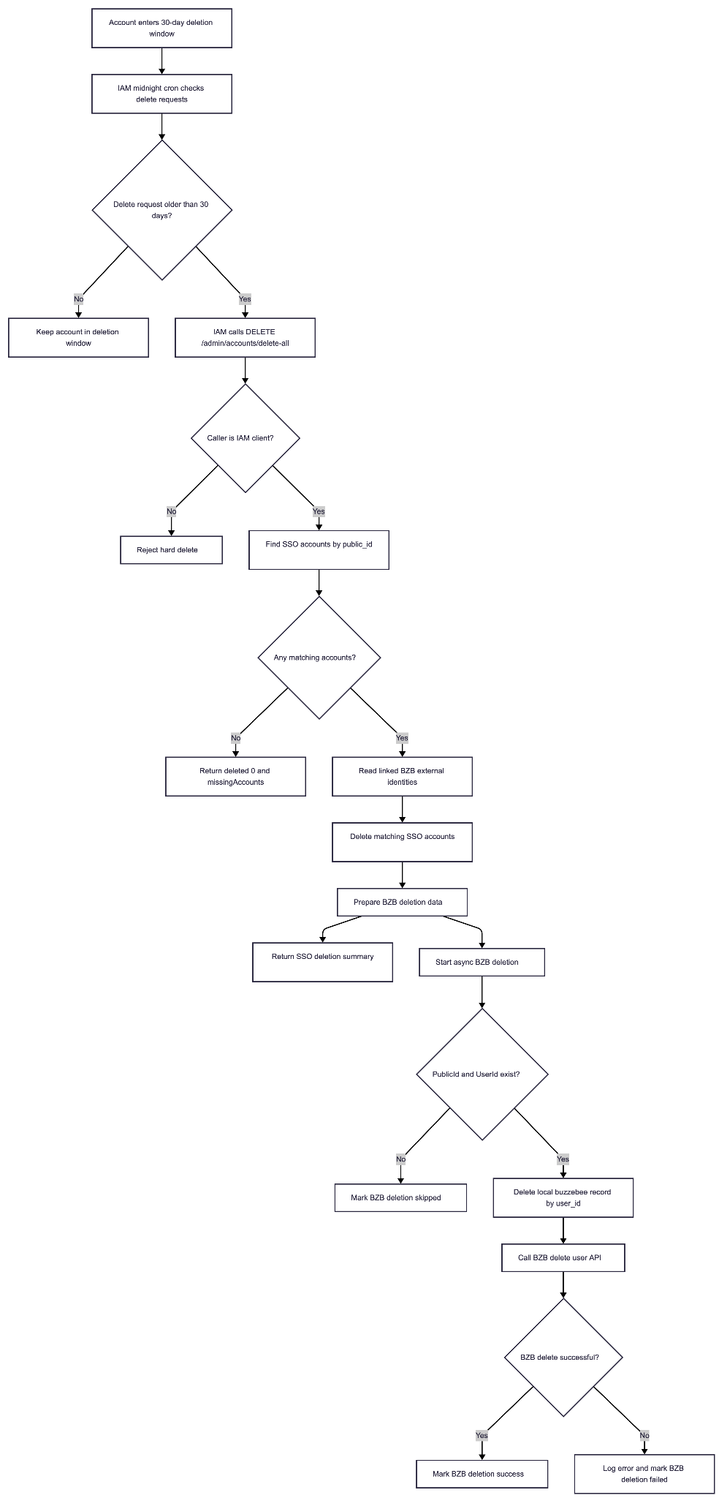

Sequence diagram

IAM
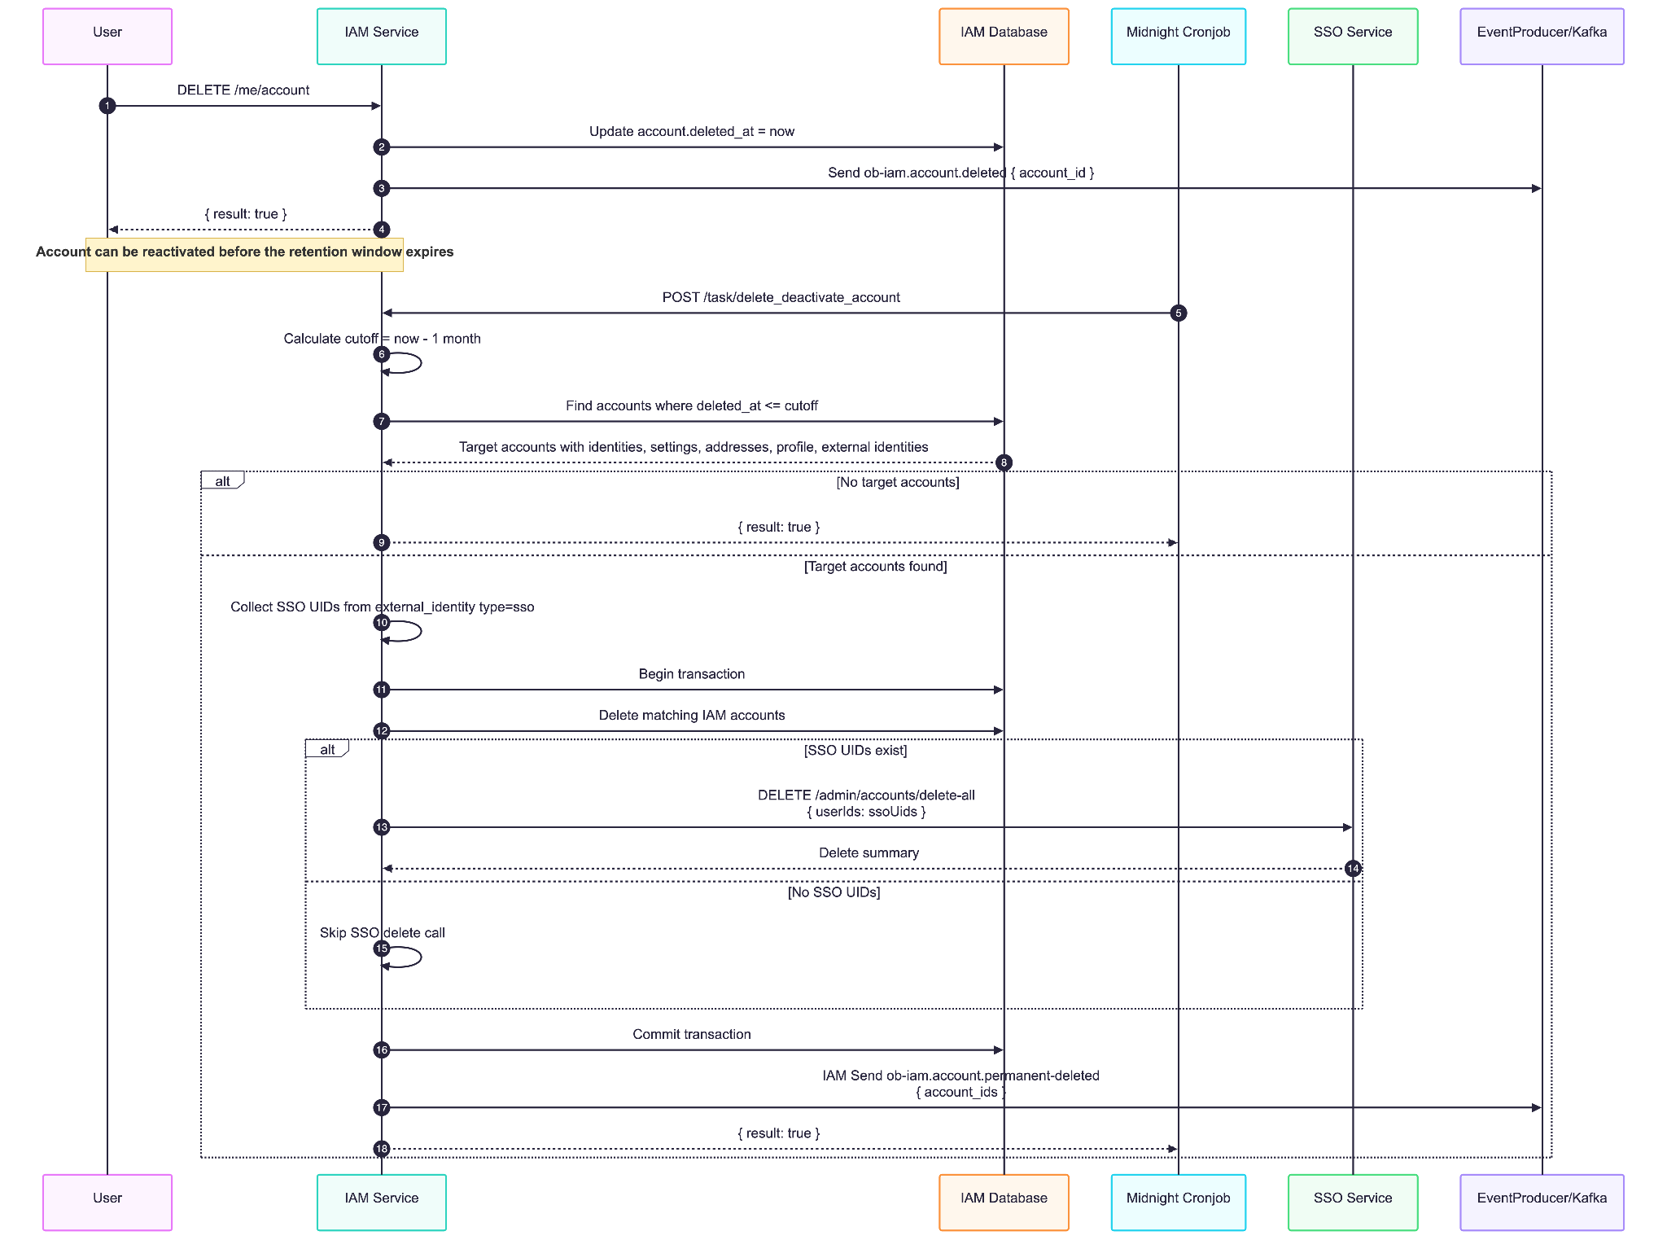

SSO
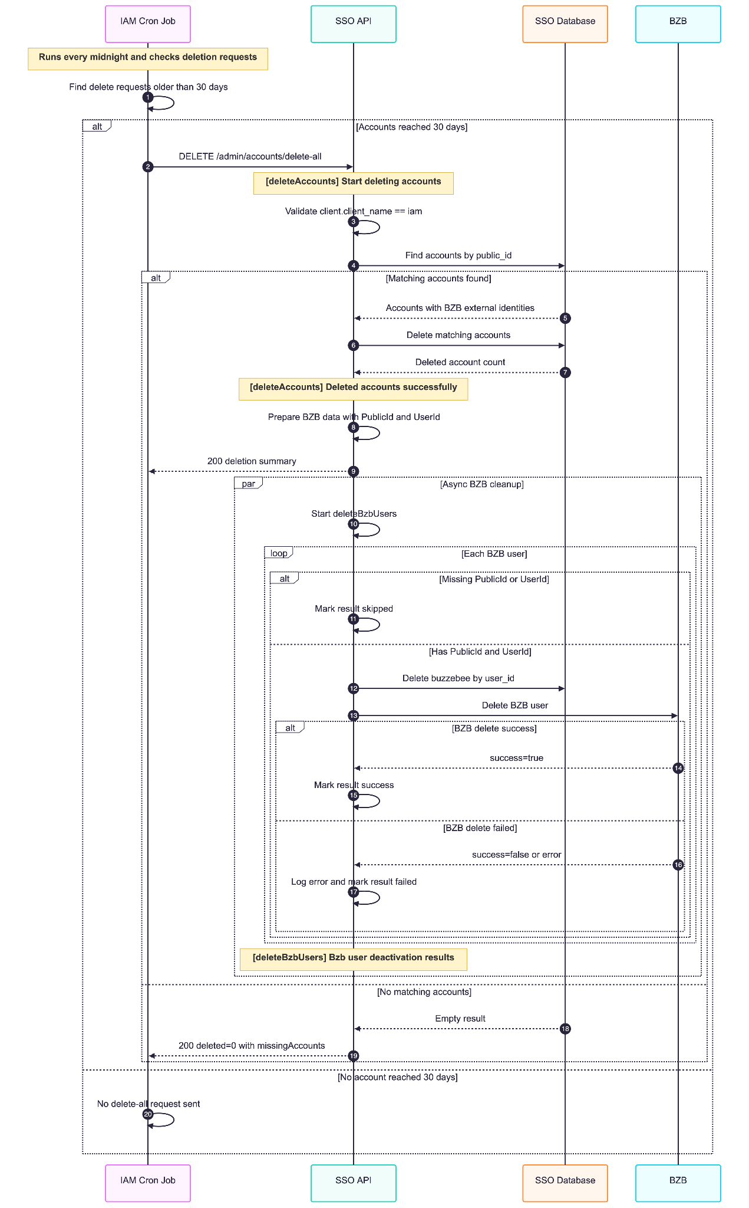

BMS
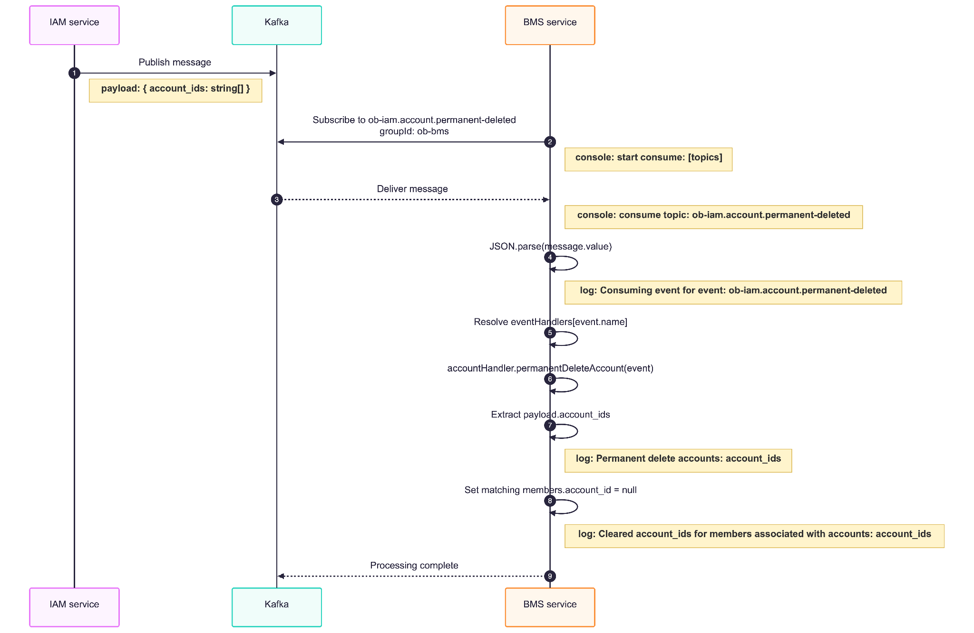

Notification
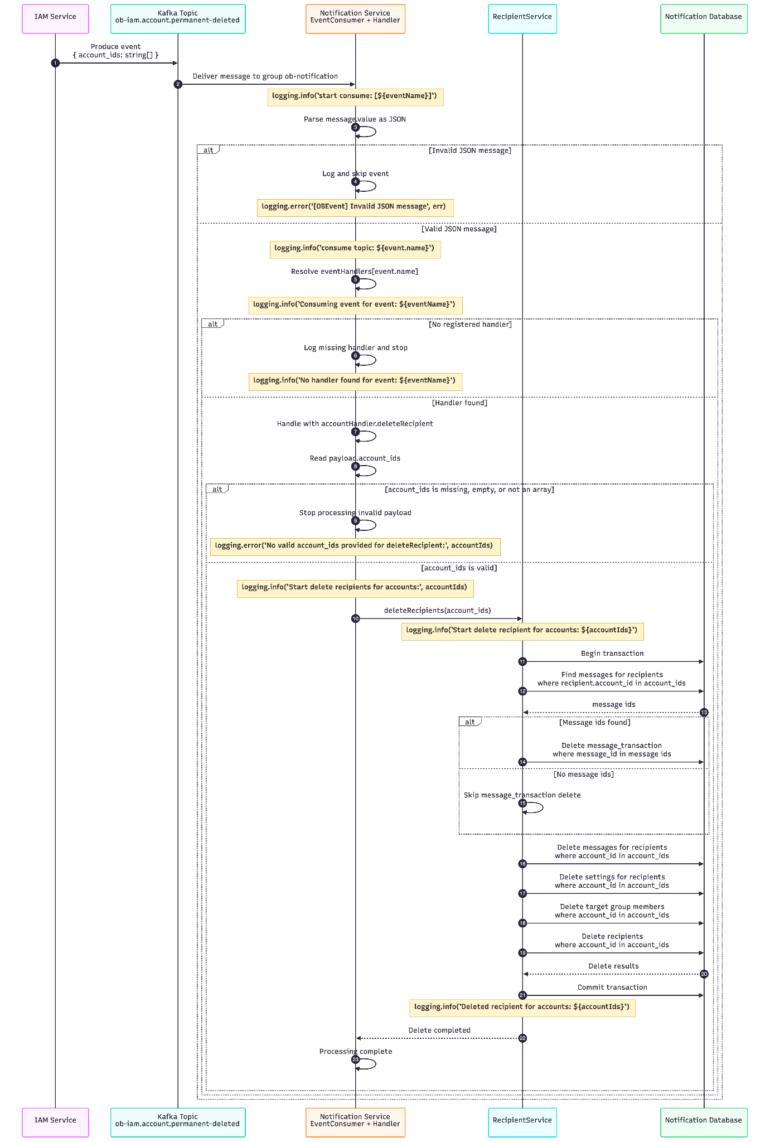

Api description - IAM

Description
A scheduled cronjob then calls POST /task/delete_deactivate_account every midnight.
The task checks for accounts whose delete request is older than the retention period and permanently removes those accounts from IAM, deletes linked SSO accounts, and publishes the ob-iam.account.permanent-deleted Kafka event.

Request Parameters
Name | Type | Required | Description
task_name | string | Yes | Must be delete_deactivate_account to trigger account permanent deletion.

Example Request
POST /task/delete_deactivate_account HTTP/1.1
Content-Type: application/json

Example Response
{
"data": {
"result": true
}
}

Error Scenarios

Error Code | HTTP Status | Message | Source | When It Happens
IAM_SSO_008 | 400 | SSO delete accounts fail | SSOClient.bulkDeleteAccount() | SSO /admin/accounts/delete-all request fails.
OB_001 | 500 | internal server error | Global error middleware / unhandled failure | Database deletion fails, transaction fails, or SSO failure is rethrown as a generic error.

Api description - SSO

Description
Permanently deletes SSO accounts after IAM determines the 30-day mark delete has passed.

Headers
Header | Type | Required | Description
clientId | string | Yes | IAM client ID.
clientSecret | string | Yes | IAM client secret.

Request Body
Field | Type | Required | Description
userIds | string[] | Yes | Non-empty list of SSO public IDs to permanently delete.

Example Request
curl -X DELETE "https://sso.example.com/admin/accounts/delete-all" \
-H "Content-Type: application/json" \
-H "clientId: iam_client_id" \
-H "clientSecret: iam_client_secret" \
-d '{
"userIds": [
"sso_1234567890",
"sso_0987654321"
]
}'

Example Response
{
"message": "Successfully deleted accounts",
"summary": {
"received": 2,
"deleted": 1,
"missingAccounts": ["sso_0987654321"]
}
}

Response Data Meaning
Field | Description
message | Human-readable deletion result message.
summary.received | Number of SSO public IDs received in the request.
summary.deleted | Number of SSO accounts permanently deleted.
summary.missingAccounts | SSO public IDs that were requested but not found in SSO.

Error Scenarios

Error Code | HTTP Status | Cause | Resolution
UNAUTHORIZED | 401 | clientId or clientSecret is missing or invalid. | Verify the client credentials sent in the request headers.
VALIDATION_ERROR | 400 | The request body does not match the Zod DTO. For example, userIds are empty. | Send the required fields using the documented types.
CLIENT_NOT_AUTHORIZED_TO_DELETE_ACCOUNTS | 500 | The authenticated client for DELETE /admin/accounts/delete-all is not IAM. The service throws Client not authorized to delete accounts. | Use the IAM OAuth client when calling the hard-delete endpoint.
ACCOUNT_DELETE_FAILED | 500 | SSO fails while finding or deleting accounts in AdminService.deleteAccounts. | Check Prisma/database logs and retry the request after the database issue is resolved.
BZB_DELETE_SKIPPED | N/A | BZB deletion data is missing PublicId or UserId. | Verify the account has a BZB external identity before the SSO account is deleted.
BZB_DEACTIVATION_FAILED | N/A | SSO account deletion succeeded, but local buzzebee deletion or the BZB delete user API failed. | Inspect [deleteBzbUsers] logs and retry BZB cleanup if required.

Event payload

Event Name
ob-iam.account.permanent-deleted

When It Is Produced
The event is produced after:
- IAM target accounts are selected.
- IAM account deletion completes.
- SSO deletion completes when linked SSO accounts exist.

Event Payload
{
"name": "ob-iam.account.permanent-deleted",
"payload": {
"account_ids": ["iam-account-id-1", "iam-account-id-2"]
}
}

Field | Type | Description
account_ids | string[] | IAM account IDs that were permanently deleted.

Consume Event Services
The ob-iam.account.permanent-deleted event is published by IAM and consumed by downstream services that need to remove or anonymize data tied to permanently deleted IAM accounts.

Notification Service
Item | Description
Consumed Event | ob-iam.account.permanent-deleted
Payload | { "account_ids": ["iam-account-id-1"] }
Purpose | Remove notification data for permanently deleted accounts.
Expected Action | Delete or disable notification tokens, subscriptions, inbox records, campaign mappings, and other account-scoped notification state.

BMS Service
Item | Description
Consumed Event | ob-iam.account.permanent-deleted
Payload | { "account_ids": ["iam-account-id-1"] }
Purpose | Remove BMS members.account_id mappings for permanently deleted IAM accounts.
Expected Action | Clear member links, resident/member bindings, tenant mappings, or other BMS records that reference the IAM account IDs.

Consumer Payload Example
{
"name": "ob-iam.account.permanent-deleted",
"payload": {
"account_ids": ["iam-account-id-1", "iam-account-id-2"]
}
}

